Storytelling Worksheet

What story does this tell?

“Forging Elite Fitness.”

How about this?

“Constantly varied functional movements performed at high intensity.”

What about this one?

“High-intensity interval training.”

What story does that tell you? What does it tell your mom or dad? What does it tell a stranger?

Stories paint pictures in our minds. The clearer the pictures, the more we believe they’re real.

Our brains are wired to remember stories, especially the ones we remember clearly.

The Answer Isn’t More Attention—It’s More Affinity

Attention alone isn’t going to help your idea gain more traction or your company make more sales. Your clients are the heroes of their own stories. Talk about their journeys.

There are five parts to a good story:

The Context—Show, don’t tell.
The Catalyst—What forced the change?
The Complication—What were the barriers?
The Change—What happened?
The Consequence—What was the result?

Great example: “Eliza Shand: Guaranteed Win”

“In January 2012, after my training session, I was invited to try out noon group. I was a bit intimidated and nervous, but with the help of a hug from someone who is now a dear friend (the hugs are still plentiful) and the encouragement and knowledge of amazing coaches, I jumped in and have been late for work since.”

A-Level, B-Level and C-Level Media

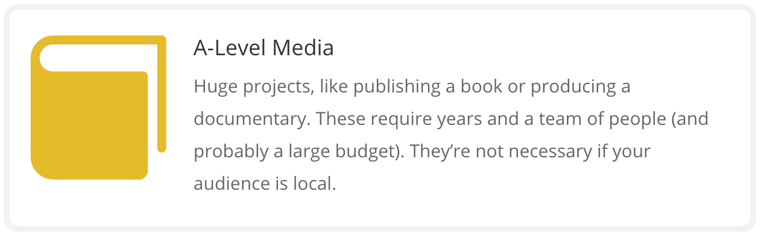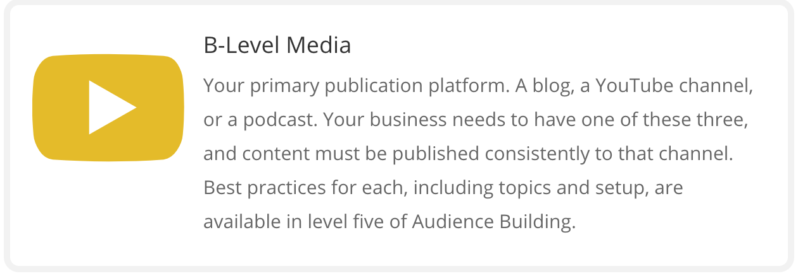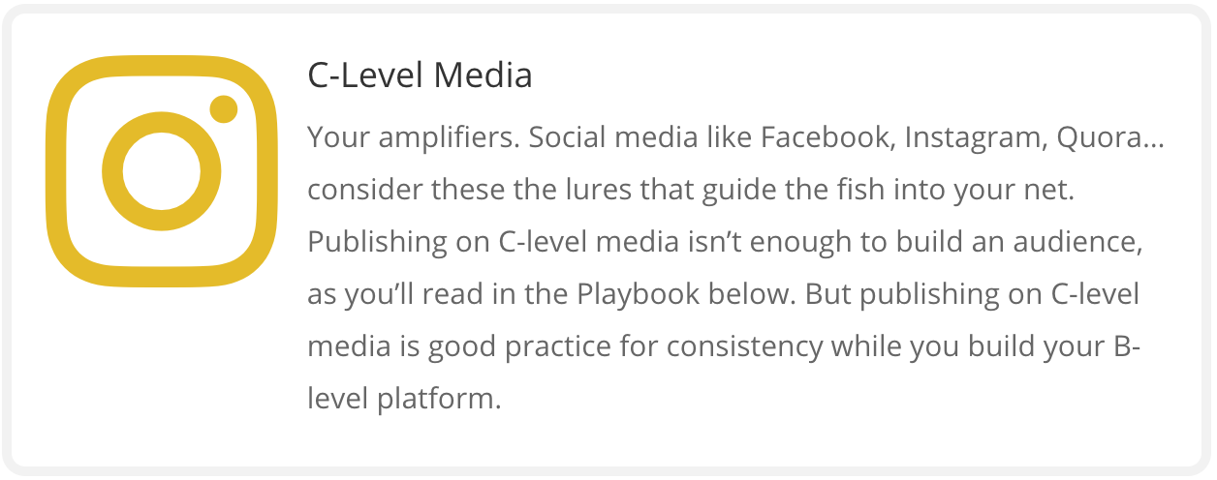

Skip A-Level Media for now.

Start with B-Level Media. Create and publish.
What to publish? The things your audience cares about.

“Your Why.”

Publish your mission. Example: “The Catalyst Mission”

“People like us do things like this.”

You have a platform. Make your clients famous: Catalyst Client Stories.

“How will your service solve my problem?”

Find the top questions your clients ask. Write the answers and publish them.

Need a kickstart? You’ll find the top 31 questions asked on Quora here (make sure you are logged in with your Two-Brain account).

Top 5 questions my clients ask most often:

1. __________________________________________________________________________

2. __________________________________________________________________________

3. __________________________________________________________________________

4. __________________________________________________________________________

5. __________________________________________________________________________

C-level Media: These are your amplifiers—Facebook, Instagram, Twitter, Reddit, Strava, LinkedIn, etc. Pick the top two your audience uses and focus on those.

Download our Social Media Playbooks from the Audience-Building Highway, Milestone 2.

Where will you publish?

Where does your audience congregate? That’s where you publish.

Write or record your story below:

Publish on two platforms where your audience is watching:

Your Story
“Who are you?” Topics
Your Why
Your Mission
Seed Client Story #1
Seed Client Story #2
Seed Client Story #3
“People Like Us” Topics
Seed Client Story #4
Seed Client Story #5
Will lifting weights make me bulky?
Can I gain muscle mass and get shredded at the same time?
What are some fitness and nutrition hacks to build muscle fast?
How do I get six-pack abs as quickly as possible?
Does weightlifting affect your joints once you are above 50?
What workout routine is best for your core muscles on a daily basis?
Can you get six-pack abs from running?
“Top Questions” Topics
What’s the hardest part of getting fit?
What is the best plan to start working out at the gym again?
What is the best plan to lose fat and not bulk up?
What are some of your personal workout or fitness center “don’ts”?
What would happen if I did pull-ups every day?
Is weightlifting at a young age bad for you?
Can you build mass with body-weight exercises?
Is it possible for the average person to maintain a ripped, muscular physique year
round without the use of steroids?
What are the best workouts to build muscle in your upper back?
Should tall people do deadlifts? Is it bad for their backs?
Do squats work your hamstrings and calves?
Why are dips harder than push-ups?
What are some unwritten rules at the gym?
How often should I squat each week to gain leg strength?
What happens if I don’t stretch after exercising?

